Cell Number

DATE: ___________________

SSN#

CONTINUE ON OTHER SIDE ->

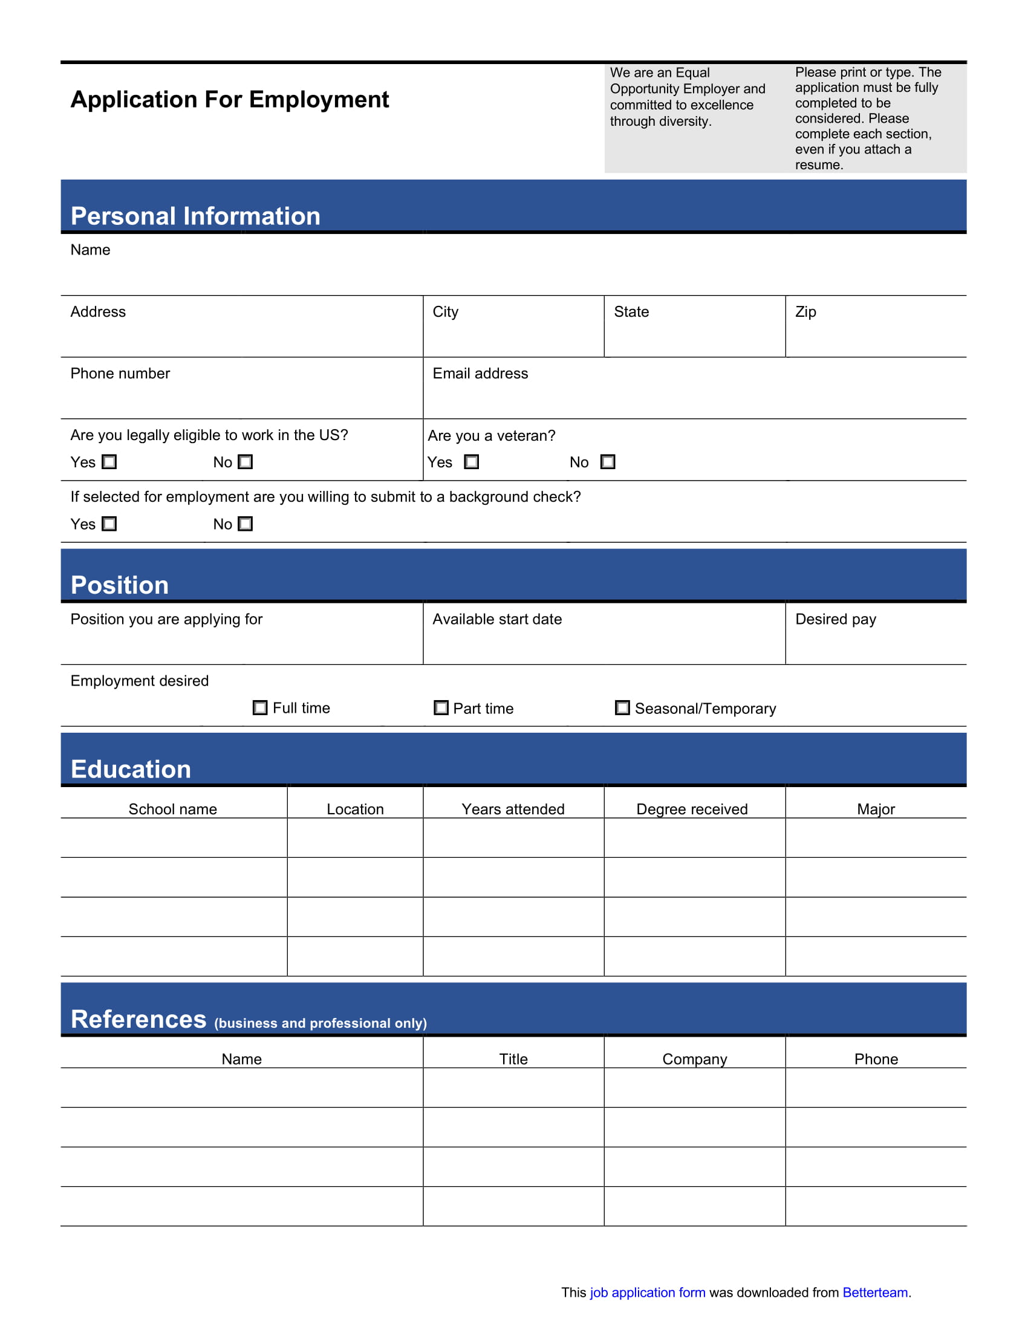

AUTHORIZATION “I authorize investigation of all statements contained herein and the references and employers listed above to give you any and all information concerning my previous employment and any pertinent information they may have, personal or otherwise, and release the company from all liability for any damage that may result from utilization of such information. I also understand and agree that no representative of the company has any authority to enter into any agreement for employment for any specified period of time or to make any agreement contrary to the foregoing, unless it is in writing and signed by an authorized company representative. This waiver does not permit the release of use of disability-related or medical information in a manner prohibited by the Americans with Disabilities Act (ADA) and other relevant federal and state laws.”

